Education Welfare Service
March 2021

Contents

1. Background 2
2. Our Structure 2
3. Introduction 3
4. The Law - Litigation and Corporate Team 4
5. Early Intervention at School – Good Practice 7
6. Attendance Panels 8
7. TAF (Team Around the Family) 9
8. Parenting Contracts 11
9. Education Supervision Order (ESO) 13
10. Fixed Penalty Notice (FPN) 15
11. Warning Letters/Attendance Planning Meetings 17
12. Section 444(1) prosecutions 19
13. PACE (Police and criminal evidence) 22
14. Appendices 23

Background
The Education Welfare Service (EWS) rejoined the Education Service in January 2018 after 3 years with the former Integrated Early Support Service. Due to re-structure, the service was reduced from 10 FTE Education Welfare Officers (EWO) to 3 FT EWOs. The EWS now makes sure the Council meets its statutory duties around school attendance, however it no longer does casework. The EWS works closely with schools though guidance to enable them to manage their attendance and provide opportunities for all pupils to attend and learn. Schools now make their own arrangements to investigate attendance issues.

Our Structure
The Education Welfare Service delivers on the Statutory Duties of the Local Authority (LA):

- Identification of Children Missing Education (CME) - (see current CME Guidance and Procedures)
- Improving attendance via investigation/enforcement process
- School Attendance Orders
- Contribute to the Code of Conduct for Fixed Penalty Notices
- Assessment of Fixed Penalty Notice Warning requests
- Assessment and Guidance for Education Act 1996 (section 444) Parental Prosecution
- Child Performance/Employment Regulation (Child Licensing)
- Right to inspect Attendance Registers

Each District has an allocated EWO to offer guidance and advice on attendance issues and the statutory duties of the LA. The team holds regular EWS District Network Meetings to provide advice and guidance on attendance issues and practice.

The team are:
Team Manager Morag Bragger 07920 295257
EWO - Chester/Rural Vacancy 07710 858754
EWO - Ellesmere Port/Neston David Williams 07768 728238
EWO - Winsford & Northwich Claire Billington 07584 206379
EWO/FPN (ULOA) Queries Jax Corbett 0751 8293728
Child Licensing Officers Gareth Lewis 07917 245769
Steph Hatton 07887832893

EWS Telephone: 01606 275759
Email: educationwelfare@cheshirewestandchester.gov.uk

Introduction
We all know good attendance, when registered at school, is essential for pupils’ learning and attainment and opens up more opportunities for their future. Facts that you will know, but are pertinent to share with pupils, parents and carers are:
- A child who is absent a day of school per week misses an equivalent of two years of their school life
- 90% of young people with absence rates below 85% fail to achieve five or more good grades of GCSE and around one third achieve no GCSEs at all
- Poor examination results limit young people’s options and poor attendance suggests to colleges and employers that these students are unreliable
- Poor school attendance is also closely associated with crime, a quarter of school age offenders have truanted repeatedly
- At least 1 million children take at least one half day off a year without permission
- 7.5 million school days are missed each year through unauthorised absence.

Absence at any stage leads to gaps in pupils’ learning. This in turn can:
- Mean that they fall behind in work
- Affect their motivation
- Affect their enjoyment of learning
- Lead to poor behaviour
- Affect their desire to attend school regularly
- Affect their confidence in school
- Mean they miss out on the social life of school and extra-curricular opportunities and experiences
- Affect their ability to have or keep friendships.

Ofsted criteria School inspection handbook sec 5 Education Act 2005
Attendance and Punctuality
175. Inspectors will consider
- Overall absence and persistent rates for all pupils and for different groups in relation to national figures for all pupils
- The extent to which low attenders are improving their attendance over time and whether attendance is consistently low (in the lowest 10%)
- Punctuality in arriving at school and at lessons
Grade descriptors for personal development, behaviour and welfare
Outstanding (1) Pupils value their education and rarely miss a day at school. No groups are disadvantaged by low attendance. The attendance of pupils who have previously had exceptionally high rates of absence is rising quickly to towards national average.

The Law - Litigation and Corporate Team

Education Act 1996 section 444
Children Act 1989 ESO (paragraph 18(1), Schedule 3, Children Act 1989
Anti-social Behaviour Act 2003

School Attendance Prosecutions
If a parent fails to get their child to regularly attend school, the School and the Local Authority (LA) should make reasonable efforts to resolve the problem before resorting to legal action. If, however, it becomes apparent that all other avenues have been explored, the information below gives information regarding the legal landscape the offences fall within.
The offences
LAs have the power to prosecute parents who:

- Fail to ensure their child’s regular attendance at school (section 444, Education Act (EA) 1996)
- Knowingly allow their child to be absent from school without authorisation (section 444(1A), EA 1996)
- Persistently fail to comply with directions given under an Education Supervision Order (ESO) ((paragraph 18(1), Schedule 3, Children Act 1989)
Only the LA can prosecute parents for the offences found in section 444 of the Education Act 1996 (section 446, EA 1996) and they must fund all associated costs.

Failure to ensure a child’s regular attendance at school (sec 444(1))
Parents are guilty of an offence for failing to ensure that their child regularly attends school (section 444(1) and (ZA), EA 1996).
With regards to the section 444(1) offence, the LA will need to prove to the criminal standard that the child is a registered pupil at a relevant school and that he is of compulsory school age and has failed to regularly attend school without authorisation. The only evidence that the LA will need to provide the court with, is the certificate of attendance and why an Education Supervision Order (ESO) is not appropriate.

Knowingly allowing a child to be absent from school without authorisation (sec 444(1A))
It is regarded as a more serious offence when a parent knowingly allows a child to be absent from school without authorisation (section 444(1A), EA 1996). In such circumstances, the LA will need to show that the child failed to regularly attend school without authorisation, and that the parents knew and failed, without reasonable justification, to ensure that their child regularly attended school.

The EA 1996 does not define “reasonable justification” but case law tells us that it is to be approached as a perfectly understandable English expression and that it was unnecessary for every single avenue to be explored to ensure that a child received “schooling”, as that was immaterial to attendance at school. ‘Reasonable justification” seems to be a question of fact relating to the child’s attendance at school and is, therefore, to be looked at in that context.
Regular attendance
The essential element in both the offences under sections 444(1) and 444(1A) of Education Act 1996 is whether the child has regularly attended school. While the term “regular attendance” has been in use since the Education Act 1944, there is no statutory definition of it.

The Supreme Court in the ‘Isle of Wight Case’ interpreted the word “regularly” in section 444(1) of the Education Act 1996, after having considered Parliament’s intention and the history of the requirement for parents to ensure their child’s attendance at school. The justices determined that “regularly” means at all times required by the rules prescribed by the school. “Full-time” education means all of the time when education is being offered to the child

Each school should have its own policy about what level of attendance it considers to be ‘regular attendance’ and when a Fixed Penalty Notice will be issued and when it will consider a prosecution. The acceptable attendance level may be different for each school. The following should be considered when deciding whether to prosecute a parent:

- The prosecution policy should be sensible. It is possible to successfully prosecute a day’s absence, but a criminal conviction may not be a proportionate response.
- The parent’s explanations for any absence may reveal problems that could be dealt with differently to resolve the non-attendance issue.
- The parent’s recognition that full-time education and school attendance is important to their child’s development.
- The clarity of the school’s policy on attendance.
- The ways that the school’s policy on absence has been sufficiently made known to parents.
- You must consider whether an Education Supervision Order (ESO) is appropriate, and detail your consideration of this in your witness statement if you decide it is not.
- If prosecution does not appear appropriate as other issues have come to light, would a Parenting Contract be of use?
- Do the issues presented by the family trigger a referral to other support agencies/organisations?
- Finally if you have decided to prosecute, would using a Fixed Penalty Notice (FPN) in the first instance be acceptable? Usually in cases where the attendance is not too bad and it is the first time the family have been in such a position. A FPN is not suitable for use in a s444(1A) case, only in a.444(1) case.
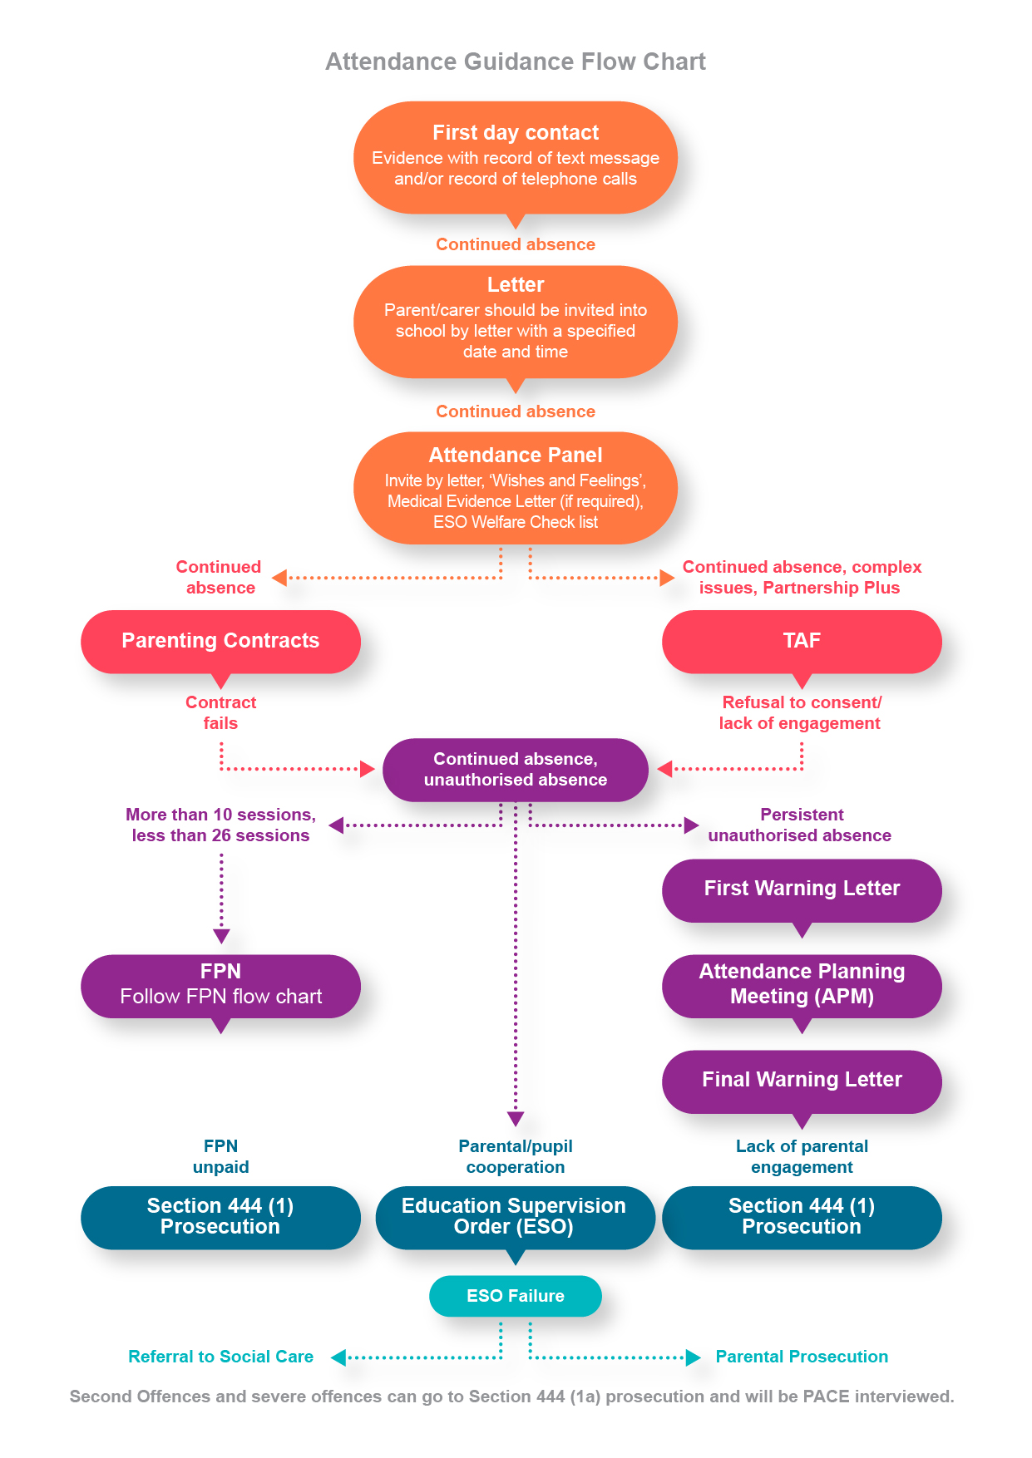

Early Intervention at School – Good Practice
(in this guidance all day to day carers will be referred to as a parent)

School Expectations of Good Attendance
To maintain the profile of ‘good school attendance’ there should be:
- a clear and coherent school attendance policy
- a named senior manager as a designated Attendance Lead
- a definition of parental responsibility for attendance, an outline of the law, the start and finish of the school day and the attendance procedure in the school prospectus, website, newsletter etc

First Day Contact - All schools should have a system of first day contact to ensure that a parent who has not notified school of their child’s absence, are contacted to ascertain the reason for absence. This is usually a text system or telephone call. All attempts to contact a parent in cases of poor attendance should be recorded and kept as evidence for any possible future legal action.

Attendance Letter - A letter should be sent home notifying the parent of the child’s absences.

Meeting - If absences continue and a parent still fails to contact school, provide a reason for absence, or the reasons for absences are questionable, a letter should be sent to invite the parent into school for a meeting. The letter must include a specified date and time to meet with a named member of staff. The letter must include the parent’s full name, the child’s name and date of birth. Please ensure that the parent names and contact details are up to date and in line with the General Data Protection Regulation 2018 (GDPR 2018)

It is at this point that all contact with the parent should be regarded as possible evidence for any future legal proceedings.

Attendance Panels
It is good practice to hold regular Attendance Panels in school as it provides opportunities for constructive communication between school and a parent. The use of Attendance Panels also concentrates resources as several families can been seen in one period of time.

A letter, including the parent’s full name, the child’s name and date of birth, should be sent to parent inviting them to attend the panel. The child may also be invited depending upon age and aptitude. Panels may vary from settings to settings and can be made up of any relevant members of staff who are working with the pupil, but the panel should be chaired by the head teacher or a member of the senior leadership team. A governor may also be invited.

Prior to the panel, ‘wishes and feelings’ should be completed with the pupil. There are many tools available in ‘Voice of the Child ‘guidance to support staff.
voice of the child

Attendance Panels provide the opportunity to consider:

- Sending a Medical evidence letter
- Using a Parenting contract (chapter 5)
- Initiating a TAF if there are multiple issues (see chapter 5)

Schools are now asked to consider an Education Supervision Order (ESO), (chapter 6) As the Litigation and Corporate team state in Chapter 4, you must consider whether an ESO is appropriate or not. You can do this at an Attendance Panel by using the Welfare Checklist list.
WELFARE CHECK LIST
. There are a number of principles, which the Children Act 1989 requires the Court to consider before making an Order.
(a) Ascertainable wishes of the child
(b) Physical, Emotional and Educational Needs
(c) The likely effect on > of any changes in his/her circumstances
(d) Any harm which > has suffered or is at risk of suffering
(e) How capable are his/her parents of meeting his/her needs
(f) Age, sex, background and any characteristics of him/her which the Court consider relevant
(g) The range of powers available to the Court under the Act in proceedings in question: Sec 36 Education Supervision Order for one year; Schedule 3 Paragraph 16 Statutory directions; Sec 37 Direction that Social Services investigate the circumstances of the child; No order.

(Appendix 1 Attendance Panel Forms)
(Appendix 2 Medical Evidence Letter)
(Appendix 3 ESO Welfare Checklist, consideration)

TAF (Team Around the Family)
The Team Around the Family (TAF) is Cheshire West and Chester’s (CWAC) approach to conducting an assessment of a family's additional needs (including the needs of the children) and deciding how those needs should be met. It is used by practitioners across children's services in CWAC. The TAF promotes more effective, earlier identification of additional needs. It provides a simple process for assessment of a family's needs and strengths, taking account of the role of parents, carers and environmental factors on children's development. Practitioners will then be better placed to agree, with the child and family, about what support is appropriate. The TAF also helps to improve integrated working by co-ordinating services and ensuring better information sharing.
You can evidence the offer of a TAF with the TAF consent form and Privacy Notice.
Links to TAF guidance and Multi-agency toolkit
CW&C Safeguarding Children Partnership

Our Way of Working
Our Way of Working is funded through the Department for Education and is being driven forward by the Children’s Trust. The vision of the programme is to support all multi-agency partners including Schools to become trauma informed in how they work with children and their families. In working in this way we are developing a culture change in practice to consider how we see all behaviour as a communication of need supporting a proactive way to understand and respond to root causes. In working in this way it will enable Schools and our partners to start to consider how to support and improve school attendance through taking a trauma informed approach.
There are many resources available to Schools on the website that can support you in starting to understand and develop a trauma informed way of working with children and families to support improved school attendance. This includes a School resource tab as well as the COVID-19 Recovery Model and Guide. Training and development programmes and workshops are also available:
Our Way of Working
COVID recovery model

Emotionally Based School Non-attendance (EBSN)
There are different reasons why children and young people (CYP) might struggle to cope in school and not attend. Emotionally Based School Non-attendance (EBSN) is a term used to describe the needs of CYP who struggle to attend school due to underlying emotional based needs, such as anxiety, unhappiness and despair. These CYP may be reluctant to leave home and can present high levels of distress in response to parents’ attempts to get them to school. This can result in prolonged absences from school.

EBSN is complex and multifaceted, requiring a holistic approach to assessment and intervention. Good practice guidance emphasises the importance of early identification and intervention to support the needs of CYP who may struggle to attend school, developing a SMART support plan, with timely review processes (CW&C, 2018).
Schools can access EBSN training and Guidance (EBSN: Good Practice Guidance for Schools) via: eCWIP for Education - Cheshire West Industry Professionals
Young Carers
Crossroad Together

Parenting Contracts
Parenting Contracts (DFE guidance)

Parenting contracts can be used in cases of irregular school attendance. A parenting contract is a formal, written, signed agreement between parents and either a LA or the governing body of a school. A parenting contract should contain a statement:

- By the parents, that they agree to comply for a specified period with whatever requirements are set out in the contract.
- By the LA, or governing body, agreeing to provide support to the parents for the purpose of complying with the contract.

The relevant legislation relating to Parenting Contracts is Section 19, Anti-Social Behaviour Act 2003 (ASB 2003): the relevant extract in relation to irregular attendance is set out below:

(2) This section also applies where a child of compulsory school age has failed to attend regularly at
(a) a relevant school at which he is a registered pupil,
(b) any place at which education is provided for him in the circumstances mentioned in [subsection (1) or (1A) of section 444ZA of the Education Act 1996], and
(c) any place at which he is required to attend in the circumstances mentioned in [subsection (1B) or (2)] of that section.
(3) A [local authority] or the governing body of a relevant school may enter into a parenting contract with a parent of the pupil or child.
(4) A parenting contract is a document which contains–
(a) a statement by the parent that he agrees to comply with such requirements as may be specified in the document for such period as may be so specified, and
(b) a statement by the [local authority] or governing body that it agrees to provide support to the parent for the purpose of complying with those requirements.
(5) The requirements mentioned in subsection (4) may include (in particular) a requirement to attend a counselling or guidance programme.
(6) The purpose of the requirements mentioned in subsection (4)–
(a) in a case falling within subsection (1) [ or (1A)]¹ , is to improve the behaviour of the pupil,
(b) in a case falling within subsection (2), is to ensure that the child attends regularly at the relevant school at which he is a registered pupil.
(7) A parenting contract must be signed by the parent and signed on behalf of the [local authority] or governing body.
(8) A parenting contract does not create any obligations in respect of whose breach any liability arises in contract or in tort.
(9) [Local authorities] and governing bodies of relevant schools must, in carrying out their functions in relation to parenting contracts, have regard to any guidance which is issued by the appropriate person from time to time for that purpose.

Parenting contracts are voluntary, but any non-compliance should be recorded by the school or LA so that it can be used as evidence in court if an application is made for a parenting order. The LA or governing body should fund any support required to implement a parenting contract (for example, a referral to parenting classes) and provide information to parents about other types of support available, such as details of national and local agencies and helplines.
(Appendix 4 Sample parenting contract)

Education Supervision Order (ESO)
- The Children's Act 1989 allows the LA to apply for an Education Supervision Order on any child of compulsory school age, whom it is felt, is not being properly educated.
- An Education Supervision Order lasts for one year initially, but may be extended for up to three years on application.
- The school will appoint a member of staff who has a good relationship with the family as a School Supervisor.
- The School Supervisor has a duty to advise, assist and support the child on whom the order has been made, and to offer support to his/her parents.
- The Supervisor will work in partnership with the child and his/her family to ensure that he/she receives an appropriate education.
- The wishes and feelings of the child must be taken into account whenever practicable.
- The Local Authority will assign a Education Welfare Officer to be a District Supervising Officer who will review the progress of the Education Supervision Order half termly.
If an Education Supervision Order is made on a child, he/she will be required to:
- Attend school regularly.
- Allow the School Supervisor to visit him/her at the place where he/she is living.
- Meet with the School Supervisor on a regular basis.
- Discuss with the School Supervisor any problems which arise which could prevent him/her attending school.
- Keep to any reasonable instruction which the School Supervisor may give.
Throughout the period of the Education Supervision Order, parents retain parental responsibility for their child, and must continue to ensure that their child attend school regularly. They must also meet with the School Supervisor on a regular basis, and allow the School Supervisor reasonable contact with the child. They must co-operate with any strategies proposed by the School Supervisor.
An Education Supervision Order is imposed when it is proved to the Court that a child is not being educated according to his age, ability and aptitude, taking into account any educational needs he/she may have. During the period of the Order, half termly review meetings will be held at which the child, parent, School Supervisor, and the District Superivising Officer discuss whether the Order is working and what future plans need to be made.
If the Order is successful, and no extension is applied for, it will lapse after the 12 month period.
If a parent does not co-operate with the School Supervisor in working within the requirements of the Order, the parent could be referred back to the Court. A fine of up to £2,500 could be imposed on the parent.
If a child does not co-operate with the School Supervisor he/she can be referred back to the Court who could direct the Social Care and Health Department to become involved and consider applying for a higher order.
(Appendix 3 A Guide to Education Supervision Orders for Parents; A Guide to Education Supervision Orders for Pupils; Directions for Education Supervision Order; ESO Statement; ESO Welfare Checklist)

Fixed Penalty Notice (FPN)

Fixed Penalty Notices are used as an early intervention to tackle low level irregular attendance. They are not to be viewed as a punitive measure or to tackle entrenched long term attendance problems. In cases of persistent absence and where there is historic absence a prosecution should be considered.
The EWS will consider issuing a FPN warning letter if the unauthorised absence is greater than 10 sessions and less than 26 sessions in a term and there is evidence of the following:

- First Day contact
- Letter to parent advising of irregular attendance
- Letter of invite to attend a meeting in school
- Letter of invite to an Attendance Panel
- Minutes of an Attendance Panel, if parent attended
- ESO consideration on the FPN Checklist form

FPN warning letters should be requested in a timely manner as historic absences will not meet legal deadlines. Requests made for warning letters relating to absences in the previous term will only be accepted in the first fortnight of the current term due to legal timeframes.
When a FPN warning letter is issued by the EWS, the school will be sent a copy of the letter and notification of the 15 day monitoring period, including the first day of the monitoring period and the last day of the monitoring period.
At the end of the monitoring period, it is the responsibility of the school to send a registration certificate to the EWS. The registration certificate must be received within 10 days of the end of the period to ensure that legal timescales are met.

- No unauthorised absence in the monitoring period, no further action and the action is closed.
- Unauthorised absences in the monitoring period, the EWS will request that a penalty notice is issued. On receiving the penalty notice, a parent has up to 21 days to pay £60 per child per parent. After 21 days and up to 28 days, the penalty notice increases to £120.
- Penalty notice is paid; there is no further action for EWS and school continues to monitor attendance.
- Penalty notice is unpaid; the EWS will complete a FPN section 9 witness statement. The school must complete a headteacher’s certificate stating the dates of the absences and the monitoring period.

(Appendix 5 Irregular attendance FPN warning letter Checklist form)
(Appendix 6 Head Teacher’s certificate)

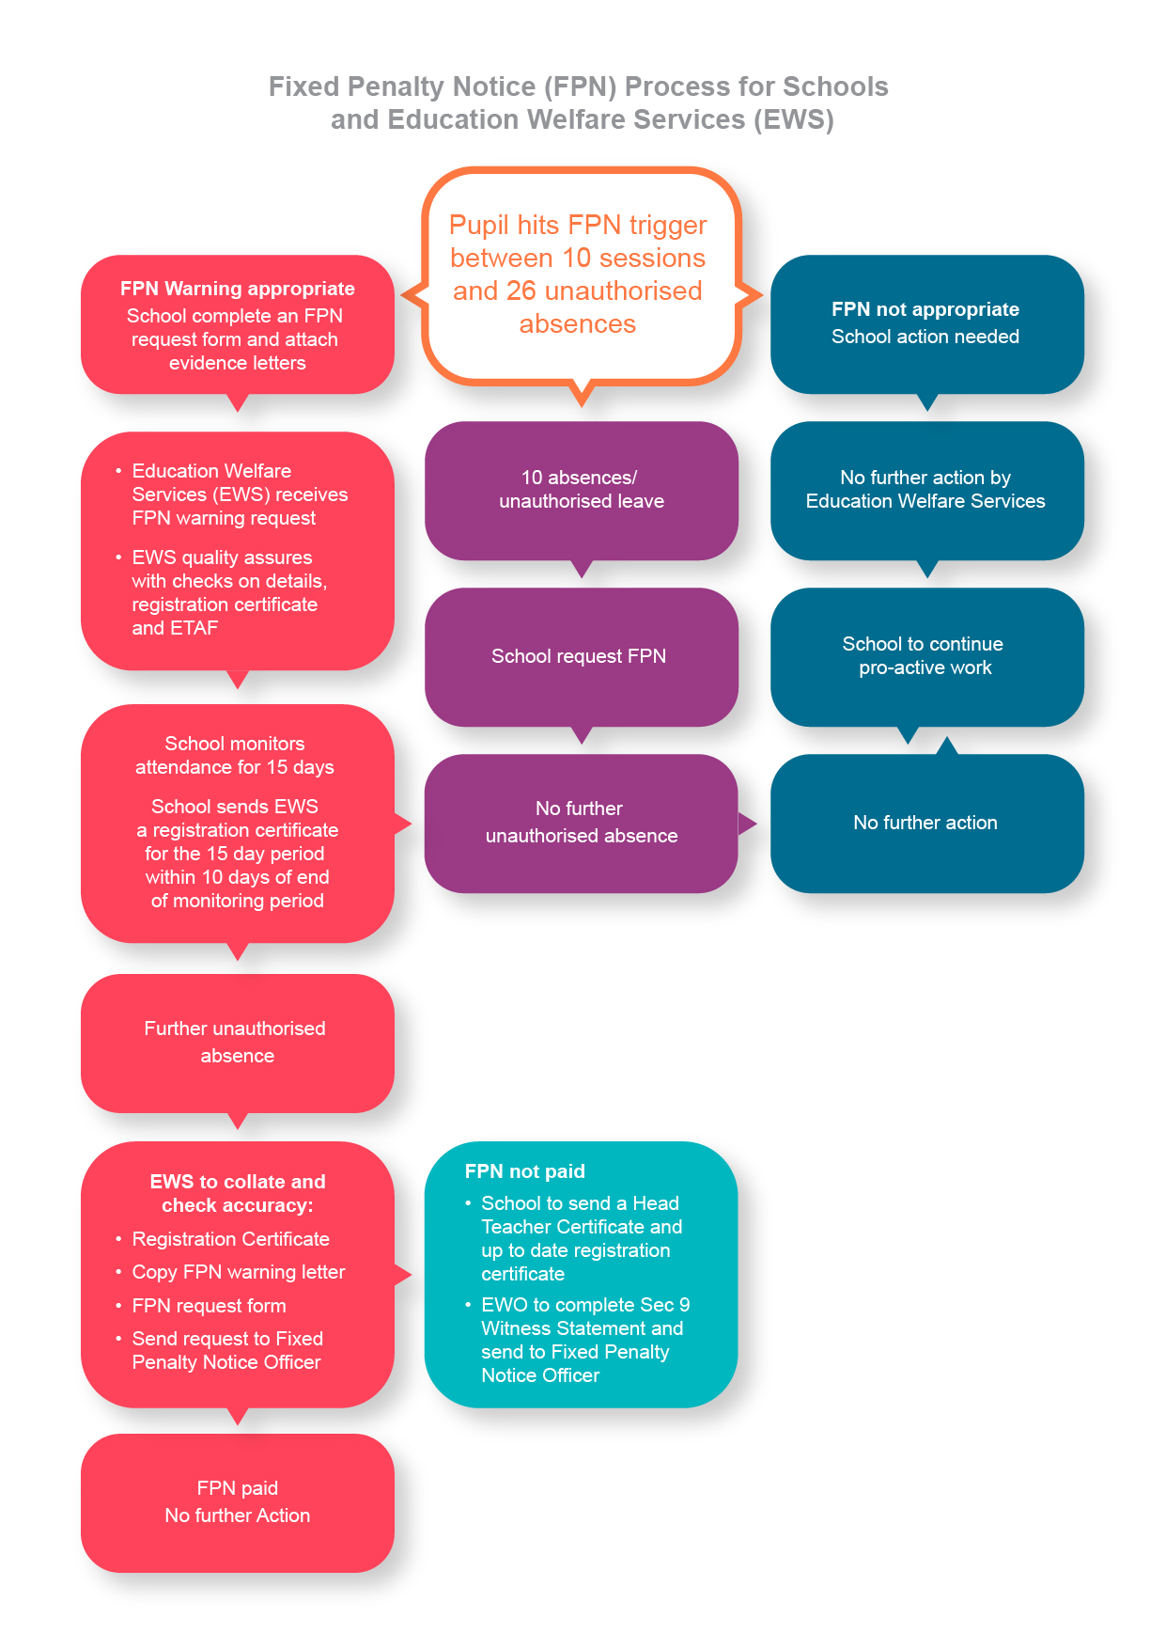

Warning Letters/Attendance Planning Meetings
First Warning Letter
For more severe and entrenched poor attendance, cases should now be considered for a Section 444 (EA 1996) prosecution.

If there is continuing irregular attendance and unauthorised absence and there is evidence that a parent is failing to ensure their child’s regular attendance at school a First Warning Letter is issued.
The letter specifies the sessions that the child has attended and the sessions he/she has been absent. The letter also states section 444, Education Act 1996) and (section 444(1A), Education Act 1996) to inform parent of their responsibility. This is evidence, in any possible future legal action, that the parent had been informed of the absence.

(Appendix 7 First Warning Letter)
Attendance Planning Meeting (APM)
If there is continuing irregular attendance and unauthorised absence, an APM should be considered after the First Warning Letter has been issued. This is a good tool to use to further investigate continued poor attendance and to warn a parent of possible legal proceedings.
This is a formal meeting and can be used as part of the legal process. A parent should be invited to attend an APM by letter. The meeting should be attended by the parent and child, relevant members of staff involved with the child, other agencies working with the child and should be chaired by a member of the senior leadership team.
It is a last chance to find solutions to improve attendance and is an opportunity to consider whether a parent meets any of the 4 statutory defences. (Education Act 1996 sec 444(3)(4))
‘The child shall not be taken to have failed to attend regularly at the school by reason of his absence from the school —
a) with leave,
(b) at any time when he was prevented from attending by reason of sickness or any unavoidable cause
(c) on any day exclusively set apart for religious observance by the religious body to which his parent belongs.
(4)The child shall not be taken to have failed to attend regularly at the school if the parent proves —
(a) that the school at which the child is a registered pupil is not within walking distance of the child’s home, and
(b)that no suitable arrangements have been made by the local education authority F2. . . for any of the following—
(i)his transport to and from the school,
(ii)boarding accommodation for him at or near the school, or
(iii)enabling him to become a registered pupil at a school nearer to his home.
(5)In subsection (4) “walking distance”—
(a)in relation to a child who is under the age of eight, means 3.218688 kilometres (two miles), and
(b)in relation to a child who has attained the age of eight, means 4.828032 kilometres (three miles), in each case measured by the nearest available route’

(Appendix 8 sample APM forms)

Final Warning Letter
If the child continues to be absent from school, after the First Warning Letter has been sent and an APM has been offered, the Final Warning Letter should now be sent.

This informs the parent that the school is referring the matter to the LA to instigate Legal Proceedings. The school can now start collating it’s evidence to write the Section 9 Witness Statement.

(Appendix 9 Final Warning Letter)

Section 444(1) prosecutions
Section 9 Witness Statement
A witness statement is a formal introduction of evidence in criminal proceedings. It provides a narrative of your involvement in a case/investigation and forms key elements of the LA’s prosecution case against a defendant. It should provide facts and details of causal connection between commission of the offence and the defendant’s role in its commission to concisely, clearly and accurately assist the Court.
Essentially it a chronology of a caseworker’s involvement in a case. Below are suggested paragraphs that should be included to logically give an account of how the case has been handled:

----------------------------------------------------------------------------------------------------------------Your Personal Details:
Name of person writing statement – job title – place of work – length of time in employment
Details of Pupil and Parent/Defendant:
Name of pupil – date of birth – year group – parent (who is defendant) – home address.
Attendance Issues:
Initial attendance concerns – figures
Case Work:
Steps taken when attendance was noticed to be in decline – did the issue continue? How was it managed? how did the family engage? What was the response of the parent, if any?
Consideration of ESO
Why has an ESO not been considerd appropriate?
Consideration of prosecution
How was the the decision to prosecute reached?
FPN Consideration
Has a FPN been requested which has been unpaid, please detail why you decided to issue an FPN in this case.
If a parent is being prosecuted and has not had an FPN, this paragraph does not been included.
--------------------------------------------------------------------------------------------------------------
This information can now be put on the sec 9 Witness Statement. The statement and the evidence below should now be sent to the EWS.

- Headteacher’s Certificate
- Registration Certificate
- Copy of warning letters sent to parents
- Copy of Medical Certificate (if relevant)
- Copy of Letters from parent, if relevant
- ESO consideration (Sec 444) form

(Appendix 10 Section 9 Witness Statement, Prosecution Chronology)

Notification of Prosecution
Once the EWS has received the legal paper work it will quality assure and check

- that an offence has been committed
- that the prosecution is fair and equitable
- it is in the public interest and good use of public monies

This is to ensure that prosecutions are safe and effective and aim to result in the outcome of improving school attendance.

The EWS will then write to the parent to notify them that legal proceedings are being instigated. School will receive a copy of this notification.

Escalation Process to Legal Intervention
Factors that may lead to prosecution:
• Unauthorised absence
• Where parent(s)/carer(s) do not respond to letters or invitations to meetings with the school and/or other partner agencies
• Where parent(s)/carer(s) do not cooperate with any interventions that are agreed as appropriate for their child in order to improve attendance
• A likelihood that court action will ensure that the pupil will return to school
• Where all other strategies have failed and evidenced in case work

Sufficient Case Work
Education Welfare Service will request hard copy of file and send to Litigation and Corporate Services
Insufficient Case Work
Education Welfare Service
to contact school

Email copy of file to the Education Welfare Service:
educationwelfare@cheshirewestandchester.gov.uk
Compile Legal File
Complete the Section 9 Witness Statement
• Include all relevant correspondence
• First Day Contact
• Letter to parent advising of Irregular Attendance
• Letter of invite to attend a meeting in school
• Letter of invite to Attendance Panel
• Minutes of Attendance Panel if attended
• ESO consideration (Welfare Checklist)
• First Warning Letter
• Letter of invite to Attendance Planning Meeting
• Minutes of Attendance Planning Meeting if attended
• Final Warning Letter
• Head Teachers Certificate and Registration Certificate
The Education Welfare Service will check and determine whether or not sufficient pre-prosecution work has been carried out to justify prosecution of the parents,
or an application for an Education Supervision Order

PACE (Police and criminal evidence)
Knowingly allowing a child to be absent from school without authorisation (sec 444(1A))

It is regarded as a more serious offence when a parent knowingly allows a child to be absent from school without authorisation (section 444(1A), EA 1996). In such circumstances, a LA will need to show that the child failed to regularly attend school without authorisation, and that the parent knew and failed, without reasonable justification, to ensure that their child regularly attended school.

A PACE interview is a means whereby evidence is gathered to show the extent of the parent’s knowledge of the non-attendance of their child and whether they have a reasonable justification. An explaination is given to the parent as to why they are being interviewed. They are allowed to gain access to a legal representative, interpreters and appropriate adults (e.g. where the parent has mental health problems) as appropriate.

Before asking any questions relating to the potential prosecution, the interviewer should explain to the parent the basis on which the interview is being conducted i.e. that the LA is considering prosecuting the parent under s 444 (1A) Education Act 1996. The interviewer should explain what the offence is and check that the parent understands what has been said. A caution is given to the parent as follows:
You do not have to say anything, but it may harm your defence if you do not mention when questioned something which you later rely on in court. Anything you do say may be given in evidence.
The interviewer should satisfy himself/ herself that the parent understands the effect of the caution. If there is any break in the interview, the parent must be reminded that they are still under caution. This would also apply if for example the caution is included in a letter inviting the parent to the meeting.
An interview should not be carried out if:
- the parent is mentally vulnerable and there is no appropriate adult available
- the parent is under the influence of alcohol or drugs
- the parent is suffering from illness, ailment or other condition which may impair their ability to understand and answer the questions put to them in interview.
An accurate record must be made of each interview stating the place and the start and end time of the record. If possible the interview should be tape recorded or through written notes.
The tape should be sealed with the date written on of the interview and parents should receive a written letter stating that the tape will be used as evidence in court.
The Interview process
- The interviewer summarises the case and sets out the facts that will be used as evidence (warning letters).
- The parent and solicitor may serve a defensive statement setting out the nature of defensive and any matters on which they take issue.
- The parent is asked about the letters that were sent out regarding their child’s attendance and any meetings which were arranged in which parent’s did not attend.
- The parent may give a further defence before the case is summarised.
(Appendix 11 PACE Chronology)

Appendices

Appendix 1 Attendance Panel Documents

Appendix 2 Medical Evidence Letter

Appendix 3 Education Supervision Order (ESO) Documents

Appendix 4 Sample Parenting Contract
Appendix 5 Irregular FPN warning letter request form (Checklist)

Appendix 6 Head Teacher’s certificate

Appendix 7 First Warning Letter

Appendix 8 Attendance Planning Meeting (APM) Documents

Appendix 9 Final Warning

Appendix 10 Section 9 Witness Statement

Appendix 11 PACE Chronology

